Mastermind Cognitive Training

🎓 Definition
# Source: ScreenShots Source: Provided by: [Persons Table -> ID Column: 1, Name_En Column: Motasem Essam] -> Tool: [Lightshot Program] -> From [Site: https://mastermindtraining.com/] on [11/14/2025]

# Source: AI Source: Provided by: [Data Path: Persons Table -> ID Column: 1, Name_En Column: Motasem Essam] -> From: [ChatGPT] on [11/14/2025]
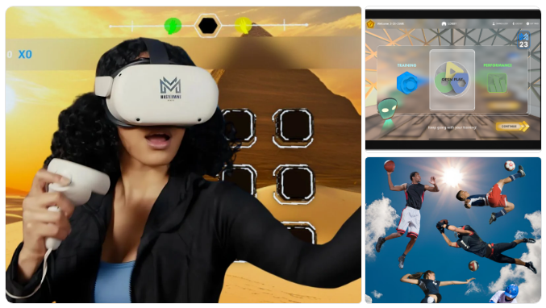
- Mastermind Cognitive Training (MCT) is a brain-training platform designed to improve cognitive skills such as attention/focus, memory, processing speed, reaction time and decision-making. (Mastermind Training)
- The platform uses gamified cognitive and eye-movement exercises, and is delivered on multiple devices (mobile/tablet, VR) so users can train in different environments. (Mastermind Training)
- The service is marketed to a wide range of groups: students/learners, athletes & teams, business professionals, seniors, public service/military first-responders. (Mastermind Training)
- It is based in Naperville, IL, in the United States. (Mastermind Training)

⚙️How it works & features
# Source: AI Source: Provided by: [Data Path: Persons Table -> ID Column: 1, Name_En Column: Motasem Essam] -> From: [ChatGPT] on [11/14/2025]
- Users begin with an initial assessment that measures baseline cognitive performance; repeats of assessments happen periodically to track progress. (Mastermind Training)
- Training sessions are typically short (about ~20 minutes) and may include combinations of eye movement protocols plus “games” that adapt to the learner’s skill level. (Mastermind Training)
- The program is delivered via:
  - Virtual Reality (e.g., Meta Quest 2/3/Pro) (Mastermind Training)
  - Mobile/Tablet app (iOS & Android) (Mastermind Training)
- The training is intended to develop “real-world” skills (or skills that transfer to real tasks): focus, reaction, coordination, visual tracking, handling multiple objects, etc. (Mastermind Training)

🎯 Purpose & Use Cases
# Source: AI Source: Provided by: [Data Path: Persons Table -> ID Column: 1, Name_En Column: Motasem Essam] -> From: [ChatGPT] on [11/14/2025]
- For education: to help students with attention, memory, processing speed which may support learning and academic performance. (Mastermind Training)
- For sports/performance: to give athletes a cognitive edge (faster reaction, sharper decision-making) in sport contexts. (Mastermind Training)
- For business/adult professional use: to improve cognitive productivity and mental agility in the workplace. (Mastermind Training)
- For seniors / aging populations: to help maintain and enhance cognitive functions (memory, speed, coordination) with age. (Mastermind Training)
- For public service / first responders: cognitive training to support performance in high-pressure or complex environments. (Mastermind Training)

🛡️ Legality & Safety
# Source: AI Source: Provided by: [Data Path: Persons Table -> ID Column: 1, Name_En Column: Motasem Essam] -> From: [ChatGPT] on [11/14/2025]
- This is a legitimate commercial/educational service, not a pirated or “questionable download” site.
- As a paid or subscription-based service (or via organizational partnership), it appears to be legally offered.
- As with all brain-training programs, one should check the scientific evidence, terms of service, and privacy/data policies—but from available information it seems reasonably presented.
- There is no obvious indication that it is illegal or unsafe in the sense of copyright infringement.

📌Summary
# Source: AI Source: Provided by: [Data Path: Persons Table -> ID Column: 1, Name_En Column: Motasem Essam] -> From: [ChatGPT] on [11/14/2025]
In short, Mastermind Cognitive Training is a modern, technology-based brain training platform, leveraging VR/mobile gamified modules to improve cognitive abilities for users in education, sports, business, aging, and high performance contexts.

